


MUMIA ABU-JAMAL ON TRUMP’S AMERICA: ‘ALL IS NOT WELL IN BABYLON’
The former Black Panther was sentenced to death in 1982 for the murder of a Philadelphia cop. His freedom is no longer a prominent cause for musicians — but he’s still paying attention
By DAVE ZIRIN
JUNE 17, 2025
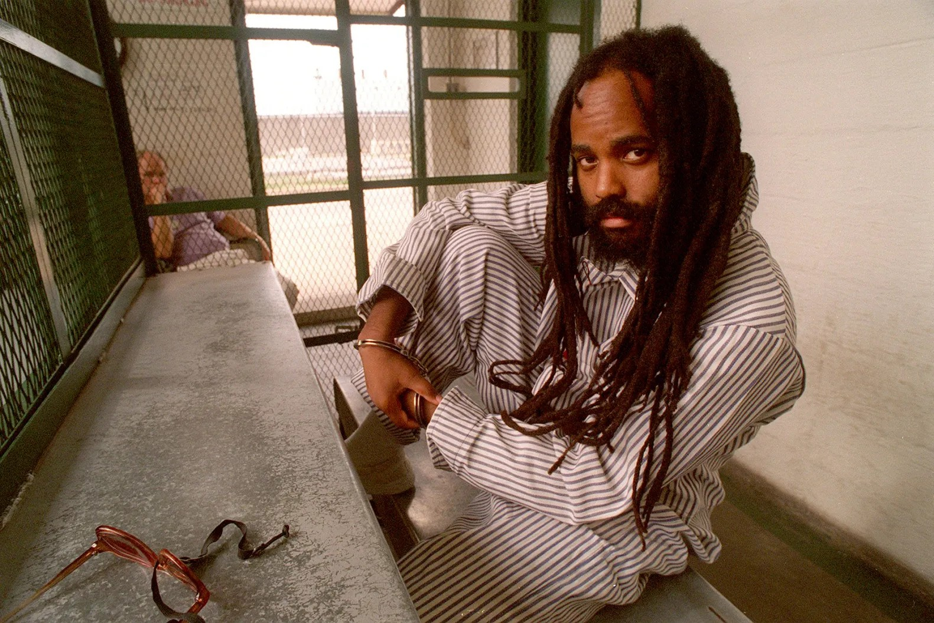
Mumia Abu-Jamal behind bars in December 2001
© APRIL SAUL/TNS/ZUMA

Seven minutes from bucolic Molly Maguire Historical Park in Frackville, Pennsylvania is the State Correctional Institution at Mahanoy. Behind the dull-grey concrete walls and razor wire, in a situation he describes as “live from slow motion death row,” is Mumia Abu-Jamal, prisoner AM 8335. At one time an international cause, Abu-Jamal spent nearly three decades on Pennsylvania’s death row, maintaining his innocence and rousing millions to call for his release. Today, more than 40 years after he was convicted of murdering police officer Daniel Faulkner, he remains a third rail in

Philadelphia politics. The Fraternal Order of Police has worked for decades first to have Abu-Jamal executed and now behind bars for killing one of their own. Amnesty International won’t take a position on his guilt, but has said his case is rife with police, prosecutorial, and judicial misconduct. In 2011, his death sentence was overturned and the District Attorney chose to not pursue it further, conceding to a sentence of life without parole. Now 71, the numbers marching for his freedom have dwindled without the urgency of imminent execution dates. But even if we’re not paying attention to him, you better believe he’s paying attention to us. “There’s a feeling of mass disorder; that everything is off of its orbit,” he says. “All is not well in Babylon.”

ADVERTISEMENT


Speaking with a direct, calm urgency, Mumia Abu-Jamal has much to say about the demise of due process, the hypocrisies of the Constitution, and the long political road that has delivered us to the current crisis. Before death row, Abu-Jamal was a youth leader for the Black Panthers and an award-winning reporter for NPR, covering culture, housing, and music. A recent president of the Philadelphia Association of Black Journalists, his future was bright. That’s what made Abu-Jamal’s 1981 arrest for the killing of Officer Faulkner over a traffic stop so difficult to believe.

ADVERTISEMENT

The state of Pennsylvania said that Officer Faulkner had pulled over Abu-Jamal’s brother, William Cook, and Abu-Jamal, then working as a taxi driver, happened to be passing by and stopped. As police and many other pro-prosecution sources have described as “a physical altercation ensued.” Abu-Jamal, the prosecution alleged, came running across the street firing a gun, killing Faulkner while taking a bullet to the stomach. The prosecution submitted examples of Abu-Jamal’s political writings as a Panther that they said demonstrated hostility to the police. Abu-Jamal has always asserted that he is a political prisoner, behind bars as part of a reactionary wave by police and prosecution against Black radicals in Philly. His trial and numerous appeals , even when new eyewitnesses came forward disputing police accounts, have not been enough to set him free.

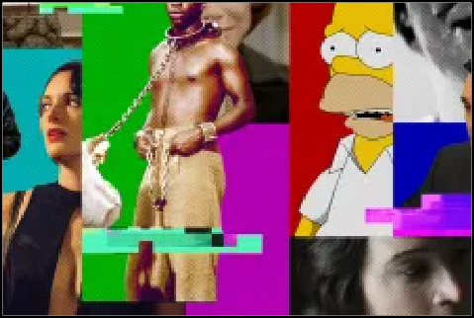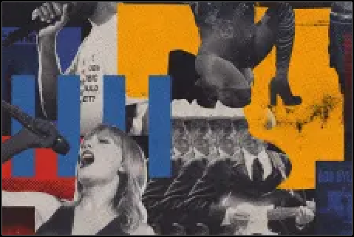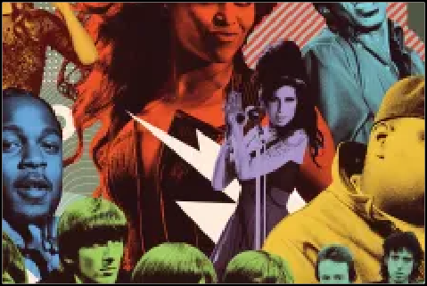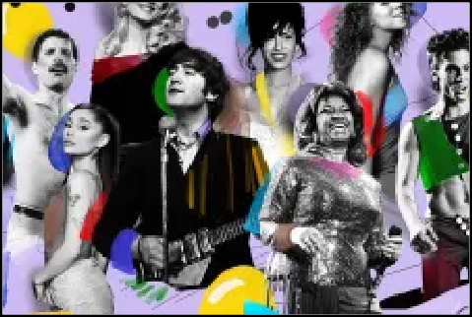EDITOR’S PICKS

The 100 Best TV Episodes of All Time

The 250 Greatest Albums of the 21st Century So Far

The 500 Greatest Albums of All Time

The 200 Greatest Singers of All Time

As execution dates approached in 1995 and 1999, Abu-Jamal’s case became a central cause for the music community. Rage Against The Machine, the Beastie Boys, KRS-One, Anti-Flag, and many more produced singles or played concerts to advocate for his freedom. But when he became a lifer without an execution date, his cause largely faded. Even as cries to “Free Mumia” have quieted, he appreciates the support he has.“I still hear from folks and I appreciate every last rap, every last word.” he says.

A self-described “history nerd” and “C-Span junkie,” Abu-Jamal has written or edited 15 books while behind bars, (including the recent Beneath The Mountain: An Anti-Prison Reader, from City Lights), and is finishing a PhD on highly influential 1950s doctor turned revolutionary Frantz Fanon at UC Santa Cruz. This is someone who not only writes

about the ugliest sides of this country, he is living it every day. Mumia and Rolling Stone were face to face in Frackville, and followed that up with a recorded phone call. I had interviewed him previously 15 years ago, but now, amid the current political upheaval, the stakes are much higher as we discuss whether the oft-discussed “road to fascism” has already arrived at a destination.
RELATED CONTENT
Billie Joe Armstrong Tells ICE to ‘F-ck Off’ in Support of L.A. Protesters Colorado Attack Suspect Charged With Federal Hate Crime
Eight Injured in What FBI Calls ‘Act of Terrorism’ in Colorado

PBS Sues Trump Administration Over Executive Order to Cut Funding

What is your life like on what you have called “slow-motion death row”?
It’s certainly quieter but also more intense in very personal ways. I spent most of my life on death row and death row was my home. It was also my office. It was a place where I worked incessantly by reading and studying. I remember I would literally read two books per day, and that was the case for weeks and months. Not because of a college education program, but out of curiosity and wanting to know how the world was put together and being free to study, to learn the answer to some of those questions. Nothing concentrates the mind like death and when reading on death row, you can travel to where your mind is: I was in other countries and other eras when I would read on the row. As for now, slow death row is still death row. It’s not a place where there’s light at the end of the tunnel. There’s just more tunnel and more darkness. (Laughs) It is a rare delight to hug one’s children and hug your wife and hug friends and talk to them, especially after 29 years without physical contact, but it’s still life in a cage, and that’s no way to live.

ADVERTISEMENT

How do you understand what you see going on politically outside the prison walls?
It’s hard not to look at the world at the present and feel a sense of profound chaos that grips one every day. It’s partly because what the country has chosen is a kind of politics of madness, of meanness and — forgive me for saying so, but I do believe this in my bones — a kind of mass ignorance that cannot be ignored. That’s the nature of this beast. It’s an extraordinary and terrifying moment.

Trump has said he doesn’t know if he agrees with the Constitution and assumed bedrock principles like due process, a trial, a jury of our peers, appear to be casualties of his justice department.
The truth of the matter is that there has always been rhetoric about due process, the right to a jury of one’s peers, and other protections offered by the constitution. But it doesn’t matter what the constitution says, what matters is what it does. There is rhetoric and there is reality, and those two rivers rarely meet. When I hear about due process, my mind automatically goes not to me and my case but to Fred Hampton, the former chairman of the Chicago chapter of the Black

Panther Party, who was killed in his bed by the government for being a Black Panther. That was Dec. 4, 1969. I speak as someone who didn’t just read articles about it. I was one of four Panthers from Philadelphia who traveled to Chicago immediately after hearing of his assassination and we stood in that house within hours of the state’s execution of Fred Hampton. We stood within two feet of his blood-soaked mattress, and not far from the door that looked like Swiss cheese because automatic weapon fire had ripped through it in the early hours of the morning. Due process, my ass.

We also now outsource prisoners, held indefinitely without trial, to an El Salvadoran labor camp built by Geo Group. It’s the expansion to the rest of the world of a prison industrial complex not content to remain in our borders. We are also seeing how easy it to repurpose these private prisons as places of repression, torture and death. These prison companies selling shares on the New York Stock Exchange are the new creators of what used to be called “black sites.” Black sites were secret prisons operated by the CIA. We never knew where they were because they never got on the news and said, “Let’s talk about where the black sites are.” Now, we trumpet it and say, “We’re going to open up a prison over there. And there and there.” It’s really the privatization of prisons gone wild and worldwide. Think of people in Germany and South Africa a century ago coming to the United States to study Jim Crow in order to perfect their own systems of racialized inequality and oppression. The U.S. is an exporter of chains.

ADVERTISEMENT

Trump’s brutality has been seen often in recent years in raids led by Democratic mayors on Occupy Wall Street protestors, BLM protestors, Cop City protestors.
Again, it doesn’t matter what the constitution says. It matters what it does. Today is the 40th anniversary of the MOVE bombing in Philadelphia. It was a liberal Democratic mayor’s office in Philadelphia that bombed a house of men, women, children, and animals, burned down several blocks, and told the fire department to cut the water off. And they did.
Eleven people, including five children, died from burns and gunfire. To be facetious, how many of those people who committed mass murder in the fifth largest city in America went to death row?

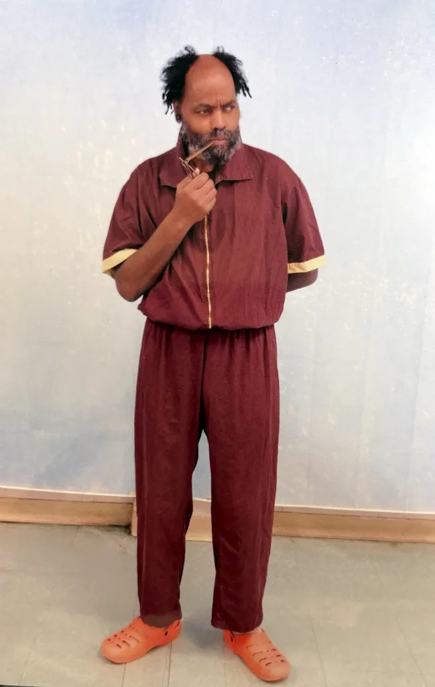
Mumia Abu-Jamal in March 2025.

As a person who was once the most well-known death row prisoner in the United States, what do you make of Trump’s desire to bring the death penalty back with a vengeance?
Again, this is the politics of repression writ large and in color. Trump’s Justice Department also speaks of reinstating the death penalty against the people who received commutations. We’re in an age of madness. Madness seems normal, doesn’t it? If you get a dose of madness every day, after a while, you almost forget how mad you are and how crazy everything else is, because it gets normalized. (Laughs) It can only get crazier because it began 30 years ago with a kind of craziness.

What do you mean by “it began 30 years ago. with a kind of craziness”?
You can’t have this law and order, anti-constitutional Trumpism without Clintonism. Bill Clinton was the godfather of mass incarceration, and you can’t talk about the expansion of the death penalty without understanding it as an extension of mass incarceration. You also could not have had mass incarceration in America without 1990s neoliberalism really

calling the tune. And neoliberalism is essentially conservatism because it’s a marriage between state and corporations, which is also a great definition for what? Fascism. It’s like polite fascism. It isn’t mean, but it has the same objective and intent. You cannot have had the exceptionalism of Trumpism without the Clinton/Biden crime bill and the mass expansion of prisons laying a road map for this.

Do we now live under fascism, a word I know you think has been overused in the past?
Yes, it is fascism. We used that word in the Sixties for political effect. We really were using it to deepen not our analysis but our rhetoric. We’re in another age right now. My understanding of fascism has always been the marriage between state and corporations. If you look at everything that’s happening around us, that marriage is being consummated repeatedly. Corporations are the main power source in our political life. Legislation is written for them, no matter what it’s about. And the U.S. Supreme Court has announced that corporations have constitutional rights and are essentially people to be protected under the Constitution.

ADVERTISEMENT

Is there a path to build a movement to defeat this fascist Trump agenda?
Waves of oppression must be met with waves of resistance, and we are now dealing with waves of madness. Any movement is going to need youth, and this generation is in many ways quite magnificent. It is the youth that always comes out and speaks about “freedom dreams” in ways that their elders are afraid to. When you’re young — especially when you’re young and in college — that is the freest time of your life. Your brain is being fed in ways that it hasn’t been in your high school days and won’t be in your post-college days. Many do not have children, they do not yet have the pressure of a career or a job, so they’re not dominated in a way that so much of the working class is. They’re free and they’re able to speak in ways that are responsive to not just their will but their heart, their spirit, and therefore, they’re able to see and rebel in ways that are unprecedented.

Think about what happened when a 17-year-old picked up a phone in Minneapolis and recorded a police officer killing someone right before her eyes. She live streamed it and it went around the world. We saw the biggest demonstrations in decades and they took place all around the world. It was like George Floyd was radiating around the world, going from phone to phone at the same time and it sparked something remarkable. A 17-year-old made that possible. I think of these young people as really incredible, and because of that powerful communication tool, they could do things that Huey [Newton] and Eldridge [Cleaver] would have dreamed of and couldn’t have pulled off! (Laughs) Because communication has been transformed.

You have spoken about reading Karl Marx for the first time at age 41. Perhaps you could speak about what Marxism has offered in terms of an analysis of our current chaos.
When I was a young Panther, I tried to read Marx. It was impenetrable. I tried to read Capital and I couldn’t get past two pages. It put me to sleep! Well, I picked it up years later, sitting on death row, and I learned some things that a 14- or 15- year-old could not have possibly learned when he began to read this stuff. I began seeing the power of having an economic analysis in order to understand how the world is organized. Marx said that capitalism is itself a revolutionary

idea that tears down all Chinese walls. It’s a destructive force that prices “things” but values nothing. This economic control over our lives — and being enslaved by the ups and downs of economic crisis — will not be stopped unless people start thinking in alternative ways. It’s important because capitalism is gangsterism on a global scale and that needs to be confronted.

ADVERTISEMENT

Yeah, they’re always quoting him in The Wall Street Journal every time there’s a crisis.
(Laughs) Which shows you they read Marx!

They’re like, “We agree with the economic analysis of capitalism, just not the whole revolution, overthrowing the system part!”
Exactly. But they know its destructive power because they’re part of it. And we’re seeing the results of a system in a constant state of crisis every day: in the world, and certainly in our politics in this country. We are amidst a white nationalist counterrevolution in Washington. Think of the federal workers under attack. You think they’re really a bunch of left-wing maniacs and socialists and liberals? No. In fact, they’re more conservative than the average worker, but this regime treated them like trash because they wanted tax cuts for the super wealthy. And they treated these people who worked their asses off — these people who went to school to learn a skill to get a job and do the best they can to help the country — like garbage. Think about the way people talk about teachers today. One of the hardest jobs in the world is to teach young people. That’s one of the hardest and one of the poorest paying gigs in the country. And when you hear politicians talk about them, they talk about them like dirt.

Why do they hate teachers so much though?
Partly because teachers represent an educated working class that questions critically the political statements politicians make. Think about the war against universities. Probably the finest creation that society has made in terms of higher education. It’s easier to have fascism with an uneducated workforce. Trump said, “I love the uneducated. They’re my favorite people.” I’ve never heard a politician say those words before him. But he means them! I think in my cell about how many of the movements of the Sixties had their birth in universities, right? Berkeley, San Francisco State, Columbia. They are at permanent war against the Sixties, probably the freest period of the Twentieth century. And they are at war with higher ed because they saw the encampments for Palestine and don’t want to see that kind of challenge again.

This is Rolling Stone and you were in part a music reporter. I know you interviewed one of my heroes, Bob Marley. I was hoping you could speak about what that was like.
That was one of the most remarkable interviews I had conducted. My baby brother, my wife and I went to a big hotel in Center City, Philadelphia. We had made arrangements with his manager, and we came up and there were Rastas walking around listening to reggae in the big room, and in the bedroom was Robert Nesta Marley. We sat down, and I must confess, he pulled out a monster spliff, and I put on a 90-minute tape to record him. And he just rolled. We talked about everything in the world in those 90 minutes until I ran out of tape and then we talked for another hour. It was partly the

spliff which he was happy to share, but more so it was the wide-open global spirit of Bob Marley. It was remarkable. He just gave it up as he saw it. “When I come to America, man, what I want to see is people rebellious, man, people Rasta.”

ADVERTISEMENT

TRENDING STORIES
- Trump Parade Turnout Swamped by Millions Who Protested at 'No Kings' Rallies

- Trump’s Military Birthday Parade Was a Gross Failure

- Beyoncé Thanks Paul McCartney for ‘Writing One of the Best Songs Ever Made’

- ‘Superman’ Director James Gunn: ‘You Don’t Want Everyone to Root for You’

You also interviewed people like The Pointer Sisters, Peter Tosh… where does your love of music come from?
Music is the closest we ever get to magic in the world. I was a kid singing tenor in the Philadelphia All-City Choir. I remember one of our biggest songs was something you’d never believe . (He sings a few bars of “Gloria in Excelsis Deo” in Latin.) Because I couldn’t read music, I had to memorize my part, so it stuck in my head forever.

Bands like Rage Against the Machine and the Beastie Boys stood up for you when you were on death row. There are also many hip hop tracks about you and for you. What did that mean to you in the 1990s when musicians were taking up your case?
It was electric; truly a wonder. My regret is that I did not get to hear most of these songs because in many of the jails I was at, we would only get local radio stations. They didn’t play hip hop, so we would get country and western nonstop, because we were in western Pennsylvania. I had some young guys who came on the row, and they would sing or recite some of the lyrics they knew, and it would blow my mind, because these were songs I had never heard. I had no idea they ever existed. Musicians are by nature the most sensitive people in our creation because, in a way, they have to be, because they’re listening to the sounds of souls to guide their art. Every one of them has magic within them. You can only have magic within to bring it out.

IN THIS ARTICLE: ACTIVISM, POLICE, TRUMP ADMINISTRATION

CULTURE > (SUB)CULTURE FEATURES
SPONSORED SľORIES

